**Jamia Millia Islamia**

**Dept. Of Computer Science**

**Big Data Assignment-3**

**Submitted By**: Wasit Shafi **Submitted To**: Dr.Mansaf Alam

**Roll no**: 18MCA054

**Q1. Are cloud computing and virtualization same Discuss virtualization architecture.**

**Sol.** No, they are different things.

A virtualization architecture is a conceptual model specifying the arrangement and interrelationships of the particular components involved in delivering a virtual -- rather than physical -- version of something, such as an operating system (OS), a server, a storage device or network resources.

Virtualization is commonly hypervisor-based. The hypervisor isolates operating systems and applications from the underlying computer hardware so the host machine can run multiple virtual machines (VM) as guests that share the system's physical compute resources, such as processor cycles, memory space, network bandwidth and so on.

**Q2.What are various types of virtualization? Discuss each one**

**Sol.**

**Types of virtualization:**

1. **Desktop Virtualization**

The virtualization of the desktop, which sometimes is referred to as Virtual Desktop Infrastructure (VDI), is where a desktop operating system (OS), such as Windows 7, will run as a virtual machine on a physical server with other virtual desktops. The processing of multiple virtual desktops occurs on one or a few physical servers, typically at the centralized data center. The copy of the OS and applications that each end user utilizes will typically be cached in memory as one image on the physical server

1. **Application Virtualization**

Application virtualization uses software to package an application into a “single executable and run anywhere” type of application. The software application is separated from the operating system and runs in what is referred to as a “sandbox.” Virtualizing the application allows things like the registry and configuration changes to appear to run in the underlying operating system, although they really are running in the sandbox. There are two types of application virtualization: remote and streaming of the application.

1. **Server Virtualization**

Server virtualization allows for many virtual machines to run on one physical server. The virtual servers share the resources of the physical server, which leads to better utilization of the physical servers resources. The resources that the virtual machines share are CPU, memory, storage, and networking. All of these resources are provided to the virtual machines through the hypervisor of the physical server. The hypervisor is the operating system and software that operate on the physical box. Each virtual machine runs independently of the other virtual machines on the same box. The virtual machines can have different operating systems and are isolated from each other.

1. **Storage Virtualization**

Storage virtualization is the process of grouping physical storage using software to represent what appears to be a single storage device in a virtual format. Correlations can be made between storage virtualization and traditional virtual machines, since both take physical hardware and resources and abstract access to them. There is a difference between a traditional virtual machine and a virtual storage. The virtual machine is a set of files, while virtual storage typically runs in memory on the storage controller that is created using software.

1. **Network Virtualization**

Network virtualization is using software to perform network functionality by decoupling the virtual networks from the underlying network hardware. Once you start using network virtualization, the physical network is only used for packet forwarding, so all of the management is done using the virtual or software-based switches. When VMware’ ESX server grew in popularity, it included a virtual switch that allowed enough network management and data transfer to happen inside of the ESX host. This paradigm shift caught the eye of Cisco, so when VMware was upgrading to vSphere 4.0, Cisco helped to write the code for VMware’s new Distributed Switch. This helped Cisco learn how to work and design network virtualization, and an internal movement was started to write all of the Cisco switches to be software-based administrative entities

**Q3. What are benefits of virtualization? Discuss role of hypervisor.**

**Sol:**

**Benefits of Virtualization**

Virtualization can increase IT agility, flexibility and scalability while creating significant cost savings. Greater workload mobility, increased performance and availability of resources, automated operations – they’re all benefits of virtualization that make IT simpler to manage and less costly to own and operate. Additional benefits include:

* Reduced capital and operating costs.
* Minimized or eliminated downtime.
* Increased IT productivity, efficiency, agility and responsiveness.
* Faster provisioning of applications and resources.
* Greater business continuity and disaster recovery.
* Simplified data center management.
* Availability of a true Software-Defined Data Center.

**Role of Hypervisor :**

Hypervisor is a form of virtualization software used in Cloud hosting to divide and allocate the resources on various pieces of hardware. The program which provide partitioning, isolation or abstraction is called virtualization hypervisor. Hypervisor is a hardware virtualization technique that allows multiple guest operating systems (OS) to run on a single host system at the same time. A hypervisor is sometimes also called a virtual machine manager(VMM).

**Q4.Discuss cloud service model and deployment model.**

**Sol.**

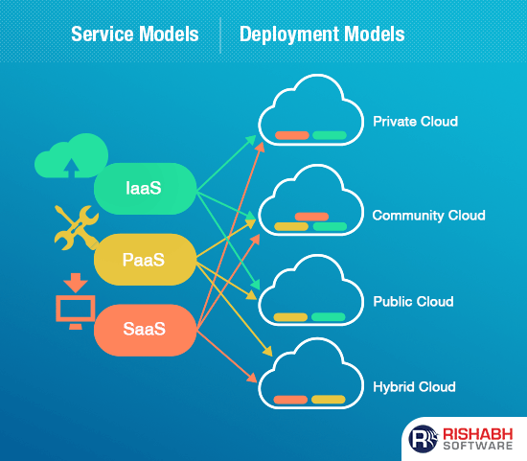

**Deployment Models**

**1. Private Cloud**

It is a cloud-based infrastructure used by stand-alone organizations. It offers greater control over security. The data is backed up by a firewall and internally, and can be hosted internally or externally. Private clouds are perfect for organizations that have high-security requirements, high management demands, and availability requirements.

**2. Public Cloud**

This type of cloud services is provided on a network for public use. Customers have no control over the location of the infrastructure. It is based on a shared cost model for all the users, or in the form of a licensing policy such as pay per user. Public deployment models in the cloud are perfect for organizations with growing and fluctuating demands. It is also popular among businesses of all sizes for their web applications, webmail, and storage of non-sensitive data.

**3. Community Cloud**

It is a mutually shared model between organizations that belong to a particular community such as banks, government organizations, or commercial enterprises. Community members generally share similar issues of privacy, performance, and security. This type of deployment model of cloud computing is managed and hosted internally or by a third-party vendor.

**4. Hybrid Cloud**

This model incorporates the best of both private and public clouds, but each can remain as separate entities. Further, as part of this deployment of cloud computing model, the internal, or external providers can provide resources. A hybrid cloud is ideal for scalability, flexibility, and security. A perfect example of this scenario would be that of an organization who uses the private cloud to secure their data and interacts with its customers using the public cloud.

**Service Models**

1. **IAAS:** Changing Its Hardware Infrastructure on Demand. The Infrastructure As A Service (IAAS) means the outsourcing of the physical infrastructure of IT (network, storage, and servers) from a third party provider. The IT resources are hosted on external servers and users can access them via an internet connection.

**The Benefits**

• Time and cost savings: more installation and maintenance of IT hardware in-house.

• **Better flexibility:** On-demand hardware resources that can be tailored to your needs,

• Remote access and resource management.

**2.PAAS:** Providing A Flexible Environment For Your Software Applications

Platform as a Service (PAAS) allows outsourcing of hardware infrastructure as well software environment, which includes databases, integration layers, runtimes and more.

**The Benefits**

• Mastering the installation and development of software applications

• Time saving and flexibility for development projects: no need to manage the implementation of the platform, instant production.

• Data security: You control the distribution, protection, and backup of your business data.

**3.SAAS:** Releasing The User Experience Of Management Constraints

Software as a Service (SaaS) is provided over the internet and requires no prior installation. These services can be availed from any part of the world at a minimal per month fee.

**The Advantages**

• You are entirely free from the infrastructure management and aligning software environment: no installation or software maintenance.

• You benefit from automatic updates with the guarantee that all users have the same software version.

• It enables easy and quicker testing of new software solutions.